**­­­­Navigating the Skies: Altitude-Distance Exploration**

**Done by Sumaiyah Abdul Aslam**

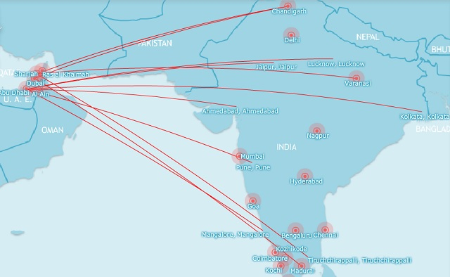

**Project Objective:**

Develop a thorough examination of aviation data to comprehend how flight altitudes, aircraft types, and trip distances relate to one another.

**Principal Objectives:**

**1. Data exploration**: Investigate flight trajectories, altitudes, aircraft types, and distances traveled by analyzing the provided aviation dataset.

**2. Correlation Analysis**: To find possible connections and patterns, examine correlations between altitude, distance, and aircraft type.

Analyze correlations between altitude, distance, and the kind of aircraft to find possible connections and patterns.

**3.Observations for Optimization**: Offer observations and suggestions for improving flight paths, altitudes, or aircraft types to reduce emissions while preserving operational effectiveness.

**4.Visualization:** Produce graphics to help stakeholders understand your results and ideas.

**Data Preprocessing Documentation**

The goal of the data preprocessing phase is to organize, clean, and get the raw dataset ready for further analysis and modeling. This includes dealing with missing values, formatting data types, and, if required, developing derived features.

**Actions Took:**

**1. Handling Missing Values:** Recognized and treated dataset missing values.

- The 'dropna()' method was implemented to eliminate rows with blank values.

**2. Data formatting:** - Using the 'pd.to_datetime()' method, the 'timestamp' column was converted to a datetime format.

- made sure that the data types for each column were adequate.

**Preprocessing advantages:**

- Missing value elimination makes guarantee that analysis is accurate without skewing results.

- Correct data formatting reduces the likelihood of mistakes in computations and displays.

- category data can be incorporated into analysis and modeling by encoding category variables.

- For accurate model training, feature scaling guarantees that numerical features have equal scales.

- Derived features such as 'duration' and 'flight distance' offer extra insights not found in the original dataset.

**Visualizations:**

